PFP - Labwork 02

Q1 (2.5 marks). Write a program that performs the following tasks:
- Input an integer number n, where n > 5 (If n≤ 5 then prompt a user to re-enter). Then calculate
- S1 = 1 + 2 + 3 + ... + n.
- S2 = n!
- S3 =1+++...+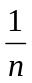.
- Re-input n. Check whether n is a prime number or not.

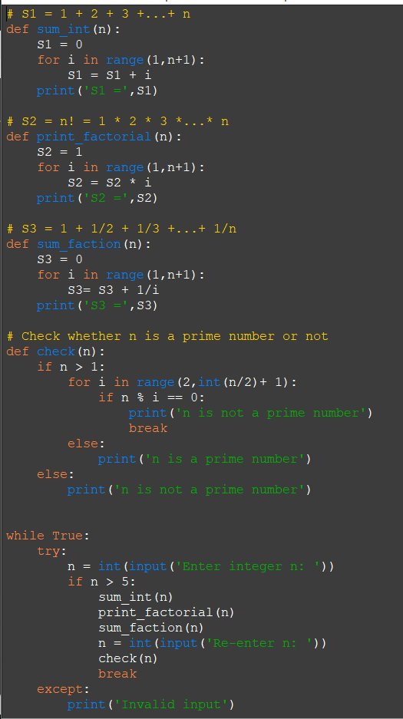

Q2 (2.5 marks). Write a program to accept 2 integer numbers m and n, then:
- Display all common prime dividers of them.
- Find the greatest common divider (GCD) of them.
- Find the least common multiple (LCM) of them.

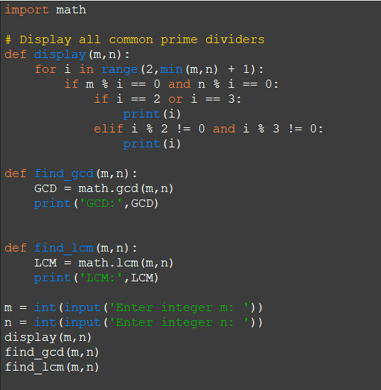

Q3 (2.5 marks). Write a program that performs the following tasks:

Write a program that allows the user to enter an integer n (n>1 and n<=9) and then print the multiplication table as shown below :
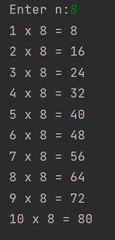

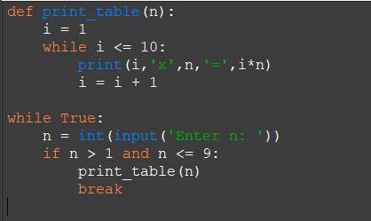

Q4 (2.5 marks). Write a program

Write a program that enters the initial deposit amount ( amount>=1000000) , the interest ( interest>0 and interest<1) per year and the number of years of deposit, calculate the amount received after n years (knowing the interest is calculated in the form of compound interest).
